Office of the General Counsel

Friday, January 21, 2022

VIA U.S. MAIL

Mr. David Boundy
Cambridge Technology, Law LLC
P.O. Box 590638
Newton, MA 02459

Dear Mr. Boundy:

As indicated in the United States Patent and Trademark Office (USPTO) Office of General Counsel response dated January 21, 2022 to FOIA Appeal No. A-22-00005, a portion of your appeal has been remanded back to the USPTO FOIA Office for process. This remand was received by the USPTO FOIA Office on Friday, January 21, 2022.

Your remand has been docketed as “FOIA Request No. F-22-00062.” Any further inquiries regarding your request should include that number. A copy of the appeal response is attached for reference and will be used as the basis for this request.

Please address all inquiries regarding your request to:

FREEDOM OF INFORMATION ACT (FOIA) OFFICER
United States Patent and Trademark Office
P.O. Box 1450
Alexandria, VA 22313-1450

Or via email to foiarequests@uspto.gov

The Agency expects to send its response to this request no later than Friday, February 18, 2022. You will be notified if it appears that additional time is required. You may check on the status of your request at the Agency’s website: www.uspto.gov, click on “Freedom of Information Act” at the bottom of the page, and then “Check FOIA Request Status.” You will need your request number, shown above, to check on the status of your request.

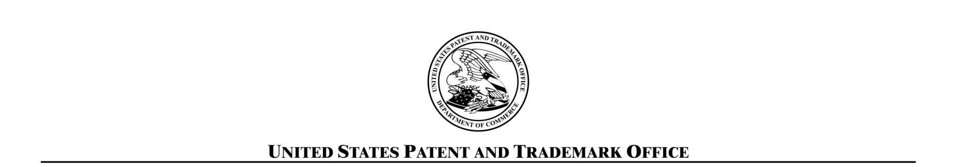
Sincerely,

USPTO FOIA Office

Enclosure

